Adaptive Coordinated Motion Control with Variable Forgetting Factor for a Dual-arm Space Robot in Post-Capture of a Non-Cooperative Target

**Abstract:** To overcome the problem of dynamics coupling between the space robot and target satellite, this paper introduces a new adaptive coordinated motion control approach with variable forgetting factor for a dual-arm free-floating space robot. Based on the reaction null space (RNS) control scheme, one arm is used to complete the capture task and the other is used to counteract the disturbance to the space base. However, when space robot captures a non-cooperative target, the system may experience output measurement noises and state disturbance, the traditional control methods often achieve poor effect in the practical application. So a recursive least square (RLS) algorithm with variable forgetting factor (VFF) is proposed in this paper to accelerate the convergence rate. Based on Lyapunov function, the convergence analysis are carried out. Finally, the simulation results demonstrate the effectiveness of the proposed algorithm.

Keywords: Coordinated Motion Control, Dual-arm Space Robot, Variable Forgetting Factor, Recursive Least Square Algorithm

**Nomenclature**

: The inertia frame

: The end-effector frame

: The rigid body 0, spacecraft

: The link  in arm-k

: The mass centre of link 

: The joint  of arm-k

: The position vector from to  and  to 

: The position vector from  to 

: The position vector of 

: The position vector of the CM of the system

: The position vector of 

: The unit vector for the rotation direction of 

: The linear and angular velocity of spacecraft

: The mass of spacecraft and link 

: The total mass of the system

: The inertia matrix of spacecraft and

: The angle vector of the joints of arm-k

: The attitude angle of the base, expressed in terms of  Euler angles

: The unit matrix

: The Jacobian matrix of arm-k

: The general Jacobian matrix of the system

: The global inertia matrix of the manipulator

: The global inertia matrix of the spacecraft

: The inertia matrix of the space base

: The coupled inertia matrix of the spacecraft and the manipulator

: The angular velocity of the target

: The linear and angular momentum of the spacecraft

: The angular momentum of the target

1. **Introduction**

With the development of astronautic technology, space robots have been playing an important role in space exploration. Their main missions include capturing and repairing non-cooperative space objects or debris, and supporting astronauts in replacing or assembling components on space stations. Therefore, many countries have paid significant attention to the development of space robotic technologies. The SUMO/FREND project and the Phoenix Program [1] exemplify typical orbital applications of space robots. The main characteristics of the two projects are that the space robots have more than one manipulator and that the inertial parameters of the target spacecraft are much larger than those of the robot.

A number of investigations on the capture of satellites and space debris have been carried out. To describe the coupling relationship between a satellite base and its mounted manipulators, researchers in this field generally tend to separate the on-orbit capture missions into four phases [2]. The first is the observing and approaching phase where a space manipulator is controlled and move toward the grasping location by gradually following the motion of the target. The second phase is capture (physical contact) phase in which the end-effector of the space manipulator physically captures the target. The third phase is to make the space manipulator firmly captures the target satellite and apply the control strategy to deal with the tumbling motion and dynamic uncertainties. The forth is the compound stabilization phase in which the space robot dampens the motion of the target. In this paper, we address the problems that arise in the post-capture and compound stabilization phase. The main topic that is presented in this paper is to minimize the disturbance to the base after capturing a large non-cooperative target satellite. This task is necessary since the antennas of the servicing base must be pointed toward the Earth and, therefore, the base attitude must be maintained.

To resolve the dynamic interaction problems of free-floating robots, a well-known concept of Reaction Null Space (RNS) control law has been widely employed. RNS control law was originally proposed by Nenchev [3] to tackle the problem of base disturbance of a free-floating space robot. Youshida [4] applied the RNS control to stabilize the base attitude in the ETS-VII project, which proved useful. In [2], the Distributed Momentum Control (DMC) strategy was proposed for capturing a tumbling satellite. The RNS motion control was employed to control the joint motion and spacecraft attitude. Recently, based on the RNS control, Huang et al.[5] planned zero-disturbance end-effector paths for a dual-arm space robot by using a dynamic balance control algorithm. However, most of the approaches mentioned above relies on the accurate dynamic parameters of the target, such as mass and moment of inertia.

In the presence of parameter uncertainties, a wide range of adaptive controller was developed for space robots. After capturing an unknown target, the adaptive techniques were proposed in [6-8] to avoid the effect of parameter uncertainties on the base attitude and achieve trajectory tracking of the end-effector. Thai-Chau and Inna [9, 10]

presented an adaptive reaction null space (ARNS) control algorithm to satisfy the objective of maintaining a minimum disturbance to the base, without knowledge of target dynamics. In the proposed adaptive approach, the recursive least squares (RLS) algorithm was employed to update reactionless joint rates for parameter adaptation in online manner. An adaptive filter was used to update the estimated parameters at each time sample. In the classical RLS algorithm, the forgetting factor is a constant with values between 0 and 1. However, it is unsuitable to track time-varying parameters since the algorithm gain converges to zero, which leads to exponential growth of the filter gain matrix [11]. In order to resolve the conflicts, numerous variable forgetting factor RLS (VFF-RLS) algorithms have been developed [12-14].

In this paper, we improve a recently proposed VFF-RLS algorithm for system identification in [14] and apply it to the ARNS motion control for a dual-arm space robotic system. This algorithm can avoid the covariance explosion problem arising in the RLS algorithm with constant forgetting factor. In this case, past data are gradually discarded on the assumption that more recent data are more informative.

The main contribution of the proposed algorithm can be stated as follows:

1. The conventional RNS motion control scheme is implemented in a dual-arm space robot, in which both arms execute ARNS motion. This adaptive control scheme is developed to stabilize a non-cooperative target that carries unknown momentum without the use of reaction wheels or jet thrust;
2. In the presence of parameter uncertainties, a VFF-RLS algorithm is implemented, which can improve the stability and accelerate the convergence rate of the tracking errors;
3. The variable forgetting factor is defined based on the prediction errors and the basic convergence analysis is carried out, which make this approach is more applicable to the robotic system.

This paper is organized as follows. In Section 2, the kinematic model of a dual-arm space robot is built and the coordinated motion equation is also obtained. Then, the adaptive reaction null space algorithm for the dual-arm space robot is developed with VFF-RLS algorithm. And then, a convergence analysis of the algorithm is conducted. In Section 5 a set of simulations is made to verify the proposed methods. The conclusions are summarized in Section 6.

1. **Dual-arm Space Robot System**

As shown in Figure 1 and Figure 2, a dual-arm space robotic system for a capture task typically consists of three major parts, a space base or servicing satellite, two arms mounted on the space base, and the satellite or the debris to be captured. In Figure 1, the space base and the two arms comprise the servicing system. In this scenario, we use one arm to complete the capture mission and the other to interact the disturbance to the base.

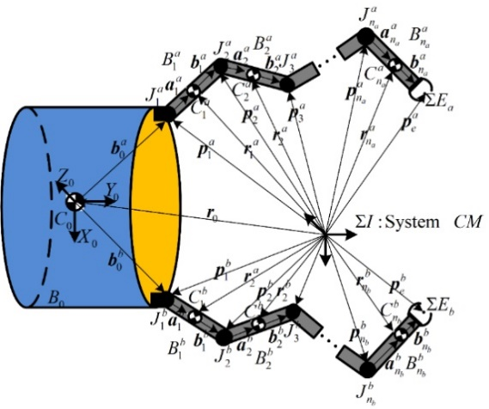

Figure 1. Dual-arm Space Robot System

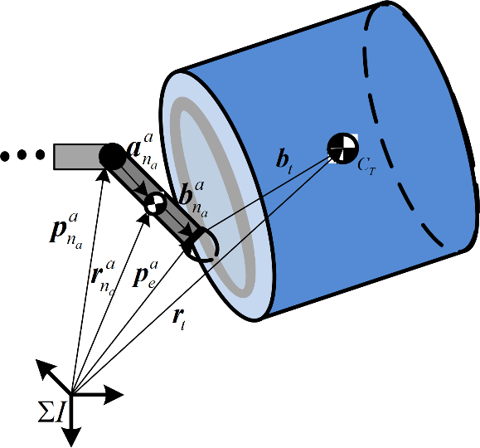

Figure 2. Part of a target captured by the space robot

The principal difference of the space robot from the ground-fixed one is that the base of space manipulators is allowed to be uncontrolled (free-floating mode operation) in the orbital environment. Special attention should be paid to the dynamic coupling between the space base and its manipulators. The kinematic and dynamic model of a dual-arm space robot has been described in [15] and [16]. To make it clear, we recall that for establishing the kinematic structure here. The body 0 in Figure 1 represents the space base of the space robot, which is connected to two manipulators, each with 3 links. Manipulator joints are revolute and have a single degree of freedom (DOF). The total DOF of the system are. The inertial position of link and end-effector in arm-k  can be written, respectively, as





Then, the linear and angular velocities' equation can be obtained according to Eq. and :









To save fuel, we have eliminated the use of reaction wheels and there are no external forces or torques acting on the space robot system, so linear and angular momentum of the system is conserved, which means  remains constant. The elements of the matrix are explicitly described in [16]:





Reformulating Eq. and in a matrix form, we obtain



Then, Eq. can be rearranged as



where



.



Then, the angular momentum conservation equation is achieved by removing the linear velocity of the space base in Eq.:



Assuming that there is no attitude disturbance and no initial momentum , yields



In this task, arm-a is used as the mission arm and planned to capture the target. Arm-b is designed as the balance arm and mainly used to maintain the base attitude; thus, the motion of the balance arm is determined by that of the arm-a: 

where  denotes the Moore-Pseudo inverse of the inertia coupling matrix .

From the Eq. and Eq. , the reaction null-space joint rates of these two arms can be obtained as





where,  denotes two null-space arbitrary vectors. The matrix  stands for the linear projector onto the null-space of matrix.

It should be pointed out that the precondition of utilizing Eq. - Eq. is that the initial angular momentum is zero. For the general case when the precondition is not satisfied and the tumbling target carries initial angular momentum , Eq. can be rewritten as follows:



where  is the initial angular momentum of the target before capture. After the target is physically attached to the end-effector, the matrix is suddenly changed and starts to include the inertia term of the target. In this context, the desired RNS motion of the two arms in Eq. and Eq. can be rewritten as





After capture, the angular momentum of the entire system becomes.  denotes the desired reactionless joint velocities of arm-k. From Eq. and Eq., it is apparent that the joint velocities comprises two parts: one from the reaction null space motion and the other from its orthogonal complement. The reaction null-space part does not contribute to the coupling momentum, and hence, it would yield zero reaction. However, due to the unknown properties of the target, we do not have the accurate knowledge of matrix . Thus, the generalized joint velocities can be rewritten in the absence of accurate knowledge of  due to the unknown properties of the target, the general solution for the joint rates can be written as





Substituting for and from Eq. and into and respectively, yields





Apparently, the expressions of Eq. and are of the same form; thus, they can be rewritten as follows:



where



Since has a full row rank and inertia matrix  is always invertible, Eq. can be rearranged as



or, more succinctly,



where .

Thus, Eq. is the foundation of the ARNS control scheme for a dual-arm space robot system. From this regression form of Eq. , it can be viewed that if the joint rates  closely follows the desired RNS joint rates ,  may converge to zero, which means that zero attitude disturbance to the base is produced. In the ARNS control scheme, Eq. is coupled with the VFF-RLS algorithm for parameter adaption.

1. **Recursive Adaptation Algorithm with Variable Forgetting Factors**

If perfect knowledge of the system properties is available, Eq. can be considered as an alternative to compute the RNS motion. However, to capture a non-cooperative target, the mission will involve an unpredictable change in the inertia properties, as well as the total momentum of the space robotic system. When the system has parameter uncertainties, one way to cope with such issue is to develop adaptive control algorithm to reduce the uncertainties. In the system identification context, the RLS algorithm with variable forgetting factor is employed to adaptively update the joint velocities on-line.

The time-varying system commonly can be represented by a linear regression equation, i.e. Eq. , which is the fundamental scheme of the ARNS motion for a dual-arm space robot system. Since the inertia properties of the manipulator are changed by the grasped target in an uncertain way, the desired joint velocity  in Eq. is redefined as



where  and  are the measured joint velocities and base angular velocity from the sensors, respectively.  is the output error vector.  is defined to present the unknown variables of the non-cooperative target.

As per [9, 10], with the measured joint rates and base angular velocity, the VFF-RLS approach can be employed to compute the updates for :













where the time index  is introduced to describe the discrete nature of the process in a practical control system, assuming a sampling rate of , and .  is the Kalman filtering gain vector, , initialized by  for , is the inverse of the correlation matrix , and  is the variable forgetting factor.  is the *a priori* estimation error, since it is computed using the adaptive filter at time  . The *a posteriori* error is defined as



The VFF-RLS algorithm results from the following optimization problem. Given  and  , determine minimization of the following quadratic cost function (see [17]):



Where  can be expressed as a quadratic form as follows:





The idea of this algorithm is to emphasize artificially the effect of current data by exponentially weighting past data values, since while space robot is grasping the target, huge impact may happen to the system, which will result in measurement errors in the sensors. Since the sequence  has the effect of attaching smaller weight to those terms in which  is expected to have larger errors, the algorithm is frequently used in the case of time-varying systems. Another use of the sequence  is to discard initial data in nonlinear estimation problems. The bad initial data may deteriorate the performance of the algorithm unless it is discarded once the algorithm is under way.

In the articles [9, 10], a constant forgetting factor  is employed, but problems can occur in an adaptive control situation. Since the matrix  changes with time, matrix  may become excessively large or approach zero.  needs to be reset to its initial value whenever it surpasses the preset thresholds; otherwise, the parameter estimator can go unstable.

To overcome this problem, the idea of exponential data weighting with variable forgetting factor is employed. It has been shown in [15] that a good choice for  in such cases is



where  is the prediction error,  is the mean value of  over a certain period, and  is a small constant, . Based on the knowledge of Kalman filtering theory [16], it can be shown that  is proportional to  and hence Eq. can be rewritten as



Unlike the traditional variable forgetting factor schemes, the proposed VFF control scheme is based on the prediction errors. The effect of the choice on the algorithm Eq. and Eq. can be explained as follows. When space robot captures the target satellite, a sudden impact in the control system occurs,  increases; this reduces  temporarily but increases  quickly so that rapid adaptation can occur. After adaptation  decreases,  returns to a value near 1. Thus the cycle will repeat itself.

Hence, the new VFF-RLS algorithm can be obtained by Eq. – Eq.. The new VFF-RLS has higher numerical stability and faster convergence than the conventional RLS algorithm in [9, 10].

Once  is calculated, the desired ARNS motion of the arms can be obtained:



The proposed ARNS scheme with variable forgetting factor requires measurements of the base angular velocity and the current joint rates. To compute the variable forgetting factor in Eq., the current prediction error  is also required. The process of the complete algorithm is presented in Figure 3, and the following primary steps are obtained below, assuming a sampling rate of :

* Step 1. Initialize the system based on pre-capture parameters , , ;
* Step 2. Measure  and ;
* Step 3. Compute  and  from Eq. – Eq.;
* Step 4. Using, update the desired motion from Eq.
* Step 5. , return to step 2 until finished

In this way, the parameter matrix and the ARNS joint rates  are updated. It is emphasized that the principal objective of the proposed control algorithm is to maintain the attitude of the space base, i.e.  after capturing a non-cooperative target. This control objective can still be satisfied even though there is an error between the estimated matrix and its true value , since the total prediction error is minimized by using VFF-RLS approach and the variable forgetting factor plays a significant role during the process of converging. As illustrated in Figure 3, the control architecture lies on two loops: the inner loop with the PD joint velocity-based controller and the outer loop with the improved VFF-RLS algorithm. The inner loop controller can drive the joint velocity error  to zero where the joint torques are computed as per the PD control law with constant gains; the outer loop can update the ARNS motion for two arms with the on-line parameter adaptation algorithm (VFF-RLS).

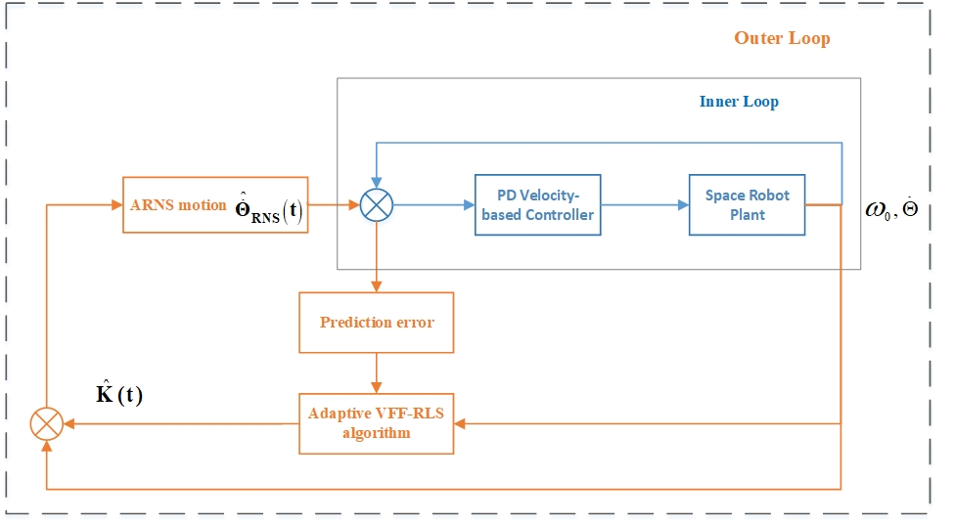

Figure 3. ARNS control scheme with VFF-RLS algorithm

1. **Convergence Analysis**

Following the proposed approach to deal with a time-varying system, the convergence properties are discussed in this section. A non-negative Lyapunov function  is defined as



Using - , we have



From Eq. and Eq., we obtain



The difference of  is given by



Inserting Eq. and Eq. to Eq. gives



Recall that  and  is a positive definite matrix and  is the maximum eigenvalue of the matrix, which is bounded, i.e.



It is clear that  is a non-negative, non-increasing function and hence it converges. Thus, we have



It is clear from the equations above that  will converge to zero. This is a desirable property and tends to improve the robustness of the algorithm.

1. **Simulation Study**

The simulation study aims to verify the capability of the proposed adaptive coordinated motion control scheme with variable forgetting factor to minimize the disturbance to the base. The verification is presented using a dual-arm planar space robot; each arm has 3 degree of freedom. The target is realistically captured by the manipulator, and the target is assumed to be firmly held by the gripper mechanism as illustrated in Figure 4.

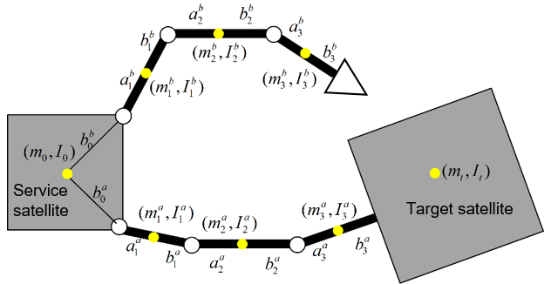

Figure 4. Dual-arm space robot with captured target

The dynamic model of the space robot and the target are created in MATLAB/SimMechanics with S-Functions. The relevant parameters of the base, links and initial states employed in this study are summarized in Table 1 and Table 2. Especially, the non-cooperative target is much larger than the space robot. The mass and inertia are assumed to be four times as large as the mass and inertia of the servicer (refer to Table 3).

|  |  |  |  |  |  |  |  |  |  |  |  |  |  |  |  |  |  |  |  |  |  |  |  |  |  |  |  |  |  |  |  |  |  |  |  |  |  |  |  |  |  |  |  |  |  |  |  |  |  |  |  |  |  |  |  |  |  |  |  |  |  |  |
| --- | --- | --- | --- | --- | --- | --- | --- | --- | --- | --- | --- | --- | --- | --- | --- | --- | --- | --- | --- | --- | --- | --- | --- | --- | --- | --- | --- | --- | --- | --- | --- | --- | --- | --- | --- | --- | --- | --- | --- | --- | --- | --- | --- | --- | --- | --- | --- | --- | --- | --- | --- | --- | --- | --- | --- | --- | --- | --- | --- | --- | --- | --- |
| Table 1. Parameters for dual-arm space robot   |  |  |  |  |  |  | | --- | --- | --- | --- | --- | --- | | Symbol | Mass (kg) | Length(m) | | Inertia | | |  |  | |  | |  | 44 | 0 | 0.3 | | 44 | |  | 2.5 | 0.2 | 0.2 | | 0.21 | |  | 2.5 | 0.2 | 0.2 | | 0.21 | |  | 2.5 | 0.2 | 0.2 | | 0.21 | |  | 2.5 | 0.2 | 0.2 | | 0.21 | |  | 2.5 | 0.2 | 0.2 | | 0.21 | |  | 2.5 | 0.2 | 0.2 | | 0.21 | | Table 2. Initial state for dual-arm space robot   |  |  |  | | --- | --- | --- | |  | Angle (deg) | Angular velocity(deg/s) | | Arm-a | [45,-45,-10] | [1.9,-2,2] | | Arm-b | [-20,20,10] | [0.3,0,0.3] | |
| Table 3. Parameters for non-cooperative target   |  |  |  |  |  | | --- | --- | --- | --- | --- | |  | Mass (kg) | Length (m) | Inertia | Angular  velocity | |  |  |  |  | | Target | 120 | 0.3 | 120 | 1.15 | |

The space manipulator initially has no momentum, and the target is tumbling with an initial angular velocity of. The initial adaptation gain matrix is defined as . The initial forgetting factor for the RLS algorithm is ; it will be reset when  or . The step size is.

Case A: Accuracy Test Case

Before the estimation of the parameter, the accuracy of the simulation platform is first ascertained by examining the momentum conservation of the system during the ARNS motion. In this case, the forgetting factor is fixed and is . In Figure 5, the system angular momenta are illustrated, depicting the process of the angular momentum distribution as the total angular momentum remains constant. The process of the distribution is slow because the target is much larger than the space robot. Figure 6 shows the ARNS motion control maintaining the base attitude while one arm holds the large non-cooperative target. Minimum base disturbance is produced by ARNS motion. In Figure 7 and Figure 8, the corresponding results are shown, which one can observe the joint motions. These results verify the accuracy of the simulation platform and its suitability for testing the proposed control concept.

|  |  |
| --- | --- |
| C:\Users\Chunting\Documents\MATLAB\ARNSC_identify_DYN_para_4\figures\Angular momentum of the system.jpg  Figure 5. Angular momentum of the system | C:\Users\Chunting\Documents\MATLAB\ARNSC_identify_DYN_para_4\figures\Base response_angular attitude and velocity.jpg  Figure 6. Base response: angular attitude and velocity |
| C:\Users\Chunting\Documents\MATLAB\ARNSC_identify_DYN_para_4\figures\Joint angles with fixed forgetting factor.jpg  Figure 7. Joint angles with ARNS | C:\Users\Chunting\Documents\MATLAB\ARNSC_identify_DYN_para_4\figures\Joint rates with ARNS.jpg  Figure 8. Joint rates with ARNS |

The results for the ARNS algorithm without variable forgetting factor that are presented here demonstrate the important role of the proposed ARNS scheme in the post-capture phase. Once the capture is established, the momentum-based parameter identification method is executed. The motions generated by the ARNS scheme provide the measurements required for solving the parameter identification problem stated in Eq. . The estimation results are shown in **错误!未找到引用源。** (a logarithmic (base 10) scale is used for the X-axis, t=20s) and Table 4. Within 0.1s after capture, the parameter estimates for, and, converge to their real values. The availability of inertial parameters for the entire base-manipulator-target system facilitates the post-capture stabilization task, since precise knowledge of space manipulator dynamics is necessary for many model-based control algorithms, such as trajectory control, optimal control or distributed momentum control.

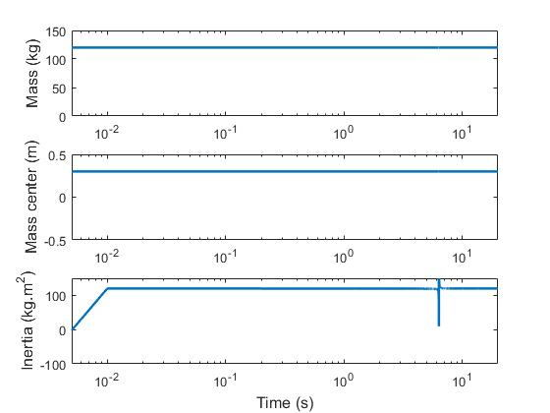

Figure 9. Estimations of inertial parameters

Table 4. Results of identification parameters

|  |  |  |  |
| --- | --- | --- | --- |
|  | Mass (kg) | Length (m) | Inertia(kg·m2) |
|  |  |  |
| Target | 119.9998 | 0.3000 | 120.0004 |

Case B: ARNS motion with VFF-RLS algorithm

The improved VFF-RLS algorithm is also employed with the ARNS motion control. The initial forgetting factor for the RLS algorithm is ; it will be reset when  or .

The results for the VFF-RLS algorithm are shown in **错误!未找到引用源。**-**错误!未找到引用源。**.

**错误!未找到引用源。** presents the original joint limit avoidance algorithm for arm-b joint 1. The joint moves around the medium position of the range. Though this algorithm manages to protect the joint from violation of the joint limit, it does not fully use the entire motion range. The improved joint-limit-avoidance algorithm overcomes this shortcoming. In **错误!未找到引用源。**, the joint moves freely in the safe area. When it passes the safe line and approaches the joint limit, it is driven to return. The maximum joint angle it reached is 58.3o. In fact, comparing the results in **错误!未找到引用源。** and **错误!未找到引用源。**, it is apparent that the improved joint-limit scheme expands the motion range. In **错误!未找到引用源。** and **错误!未找到引用源。**, the other joint angles are shown. A comparison of the joint rates profiles in the square frame in **错误!未找到引用源。** reveals that when the first joint turns around to escape the joint-limit area, the second and third joints attempt to compensate for the change of the first joint. This response demonstrates that the joint limit avoidance task of the proposed control law is completely satisfied. As shown in **错误!未找到引用源。** and Figure 15, during the time period of 10-14 seconds, the potential function is forced to decrease whenever the joint approaches its limit; the function acts as a penalty function that returns a high weight under this scenario.

In this test case, the attitude disturbance to the base is shown in **错误!未找到引用源。**. Compared with that shown in **错误!未找到引用源。**, the performance of the base response worsens, especially when the joints approach their limits. When the joints remain in a safe area, no significant difference is observed in the base response.

|  |  |
| --- | --- |
| C:\Users\Chunting\Documents\MATLAB\ARNSC_identify_DYN_para_4\figures\Arm-a_angulars.jpg  Figure 10. Arm-a joint angles | C:\Users\Chunting\Documents\MATLAB\ARNSC_identify_DYN_para_4\figures\Arm-b_angulars.jpg  Figure 11. Arm-b joint angles |
| C:\Users\Chunting\Documents\MATLAB\ARNSC_identify_DYN_para_4\figures\Arm-a_rates.jpg  Figure 12. Arm-a joint rates | C:\Users\Chunting\Documents\MATLAB\ARNSC_identify_DYN_para_4\figures\Arm-b_rates.jpg  Figure 13. Arm-b joint rates |
| C:\Users\Chunting\Documents\MATLAB\ARNSC_identify_DYN_para_4\figures\Base_disturbance.jpg  Figure 14. Disturbance to the base | C:\Users\Chunting\Documents\MATLAB\ARNSC_identify_DYN_para_4\figures\VFF.jpg  Figure 15. Variable forgetting factor in ARNS |

Case C: Controller Analysis

For evaluating the performance of the proposed PD-type iterative learning controller, the torques of the system are studied here. Note that the PD-type iterative learning control gains are the same with that of the PD controller. They are presented in Table 5. The positive number is defined as . Once we have  , the learning process stops and the controller switches from PD-type iterative learning control to PD control.

Table 5. The gains of the controller

|  |  |  |  |  |  |  |
| --- | --- | --- | --- | --- | --- | --- |
| Joints |  |  |  |  |  |  |
|  | 300 | 200 | 150 | 30 | 200 | 150 |
|  | 20 | 15 | 10 | 20 | 15 | 10 |

Figure 16 and Figure 17 depict the torque differences between the PD control and the PD-type iterative learning control. The error profiles of the PD controller and PD-type iterative controller are shown in Figure 18 and Figure 19. To clearly show the convergence rate, a logarithmic (base 10) scale is used for the X-axis (t=20s). The performance improvement is unambiguous, where the convergence time is  and , respectively. The effectiveness of the PD and PD-type iterative learning control law can be explained as follows: before the iterative learning control is employed, nothing is known about the target in the control scheme; thus, the system can be treated as a black box. After the first iteration, the PD-type iterative learning control law obtains some dynamic information about the target, and the system becomes a gray box. As the iterations go on, more knowledge of the inertia parameters is obtained and added to the control law. Therefore, the PD-type iterative learning control law offers a faster convergence rate than that of the typical PD control, which is advantageous for applications involving the capture of a large non-cooperative target.

|  |  |
| --- | --- |
| C:\Users\Chunting\Documents\MATLAB\ARNSC_identify_DYN_para_2\PDIL\PD_Torque.jpg  Figure 16. PD control law | C:\Users\Chunting\Documents\MATLAB\ARNSC_identify_DYN_para_2\PDIL\IL_Torque.jpg  Figure 17. PD-type iterative learning control law |
| C:\Users\Chunting\Documents\MATLAB\ARNSC_identify_DYN_para_2\PDIL\PD_Angular_error.jpg  Figure 18. Joint rates error of PD control | C:\Users\Chunting\Documents\MATLAB\ARNSC_identify_DYN_para_2\PDIL\IL_Angular_error.jpg  Figure 19. Joint rates error of PD-type iterative learning control |

1. **Conclusion**

In the course of on-orbit servicing, the tumbling target was assumed to be much larger than the space robot, which meant that the uncertainties of the inertia properties of the target would degrade the control performance and the compound stabilization. To address this problem, this article presented a new adaptive coordinated motion control for a dual-arm space robot. The advantage of this control scheme was that it was designed for the capture of a large unknown tumbling target. With the proposed adaptive coordinated motion control strategy, three relevant problems of post-capture control of a dual-arm space robot were addressed simultaneously: maintaining minimum disturbance to the base by manipulator-target motion, avoiding joint limits and identifying the target’s properties in real time. A PD-type iterative learning control algorithm was also presented to accelerate the convergence rate of the tracking errors. The simulations revealed that the proposed methods were applicable to a dual-arm space robot supplying on-orbit services.

Based on the proposed methods, several recommendations for further research can be made as follows:

The dynamic singularity issue should be addressed for the dual-arm space robot. Due to a lack of the accuracy knowledge of dynamic properties, the singularity problem may be more complex after capturing an unknown target.

The closed-chain constraints should be investigated in future. To manipulate a large target, the dual-arm space robot and the target may form a closed-chain system. New planning and control algorithms should be proposed to deal with such constraints.

Constructing the experimental test-bed and actual experimental validation of the proposed methods are strongly recommended for future work.

**Acknowledgements**

This work has been supported by the Tsinghua National Laboratory for Information Science and Technology, Shenzhen Key Lab of Space Robotic Technology and Telescience, and the Natural Science Foundation of Guangdong (No. 2015A030313881).

**References**

[1] T. Debus and S. Dougherty, "Overview and Performance of the Front-End Robotics Enabling Near-Term Demonstration (FREND) Robotic Arm," in *AIAA Infotech@Aerospace Conference*, 2009.

[2] D. N. Dimitrov and K. Yoshida, "Momentum distribution in a space manipulator for facilitating the post-impact control," in *2004 IEEE/RSJ International Conference on Intelligent Robots and Systems (IROS) (IEEE Cat. No.04CH37566)*, 2004, vol. 4, pp. 3345-3350 vol.4.

[3] D. N. Nenchev, K. Yoshida, P. Vichitkulsawat, and M. Uchiyama, "Reaction null-space control of flexible structure mounted manipulator systems," *IEEE Transactions on Robotics and Automation,* vol. 15, no. 6, pp. 1011-1023, 1999.

[4] K. Yoshida, K. Hashizume, and S. Abiko, "Zero reaction maneuver: flight validation with ETS-VII space robot and extension to kinematically redundant arm," in *Proceedings 2001 ICRA. IEEE International Conference on Robotics and Automation (Cat. No.01CH37164)*, 2001, vol. 1, pp. 441-446 vol.1.

[5] H. Panfeng, X. Yangsheng, and L. Bin, "Balance control of multi-arm free-floating space robots during capture operation," in *2005 IEEE International Conference on Robotics and Biomimetics - ROBIO*, 2005, pp. 398-403.

[6] S. Abiko and K. Yoshida, "Adaptive Reaction Control for Space Robotic Applications with Dynamic Model Uncertainty," *Advanced Robotics,* vol. 24, no. 8-9, pp. 1099-1126, 2010/01/01 2010.

[7] S. Xu, H. Wang, D. Zhang, and B. Yang, "Adaptive Reactionless Motion Control for Free-Floating Space Manipulators with Uncertain Kinematics and Dynamics," *IFAC Proceedings Volumes,* vol. 46, no. 20, pp. 646-653, 2013/01/01 2013.

[8] P.-C. Cong, Y. F. Lan, and X. Zhang, "Adaptive control of dual-arm space manipulator capturing object," *Proceedings of the Institution of Mechanical Engineers, Part G: Journal of Aerospace Engineering,* vol. 227, no. 6, pp. 992-999, 2013/06/01 2012.

[9] T. C. Nguyen-Huynh and I. Sharf, "Adaptive reactionless motion for space manipulator when capturing an unknown tumbling target," in *2011 IEEE International Conference on Robotics and Automation*, 2011, pp. 4202-4207.

[10] T. C. Nguyen-Huynh and I. Sharf, "Adaptive ReactionLess motion with joint limit avoidance for robotic capture of unknown target in space," in *2012 IEEE/RSJ International Conference on Intelligent Robots and Systems*, 2012, pp. 1155-1160.

[11] Z. Lakhdari, M. Mokhtari, Y. Leluse, J. Provost, Adaptive predictive control of a class of nonlinear systems: A case study, IFAC Proceedings Volumes 28 (13) (1995) 209 - 214, 5th IFAC Symposium on Adaptive Systems in Control and Signal Processing, Budapest, Hungary, 14-16, June, 1995.

[12] Y.-H. Jia, Q. Hu, and S.-J. Xu, "Dynamics and adaptive control of a dual-arm space robot with closed-loop constraints and uncertain inertial parameters," *Acta Mechanica Sinica,* journal article vol. 30, no. 1, pp. 112-124, 2014.

[13] K. Yoshida and S. Abiko, "Inertia Parameter Identification for a Free-Flying Space Robot," in *AIAA Guidance, Navigation, and Control Conference and Exhibit*(Guidance, Navigation, and Control and Co-located Conferences: American Institute of Aeronautics and Astronautics, 2002.

[14] K. Yoshida, R. Kurazume, and Y. Umetani, "Dual arm coordination in space free-flying robot," in *Proceedings. 1991 IEEE International Conference on Robotics and Automation*, 1991, pp. 2516-2521 vol.3.

[15] G. C. Goodwin and K. S. Sin, *Adaptive Filtering Prediction and Control*. Dover Publications, Inc., 2009, p. 560.

[16] C. Paleologu, J. Benesty, and S. Ciochină, "A practical variable forgetting factor recursive least-squares algorithm," in *2014 11th International Symposium on Electronics and Telecommunications (ISETC)*, 2014, pp. 1-4.

[17] S. Jianjun, D. Xiaoping, W. Chao, W. Qiao, L. Xin, and J. Yu, "Mass Characteristic Parameter Identification for a Space Robot Based on Angular Momentum Conservation," in *2011 International Conference in Electrics, Communication and Automatic Control Proceedings*, R. Chen, Ed. New York, NY: Springer New York, 2012, pp. 333-340.